**Chapter 1**

**ABOUT THE COMPANY**



L2M Rail private limited (an IISc startup) aims at developing Technologies which can make the rail networks safer than ever before. It also aims at developing the components indigenously with thorough research in development. The sensors developed based on the concept of fibre brag grating are extremely sensitive and serve as a reliable means of sensing mechanism for the system. The company holds several patents in in the area of sensors and such other systems which can be efficiently utilized for the purpose of developing energy efficient and safety solutions for the modern world. They also aim at minimizing the human role and thereby make it fool proof with necessary technology.

The team of L2M Rail is led by two renowned professionals who have reached the Pinnacle in their career. Professor Dr R K Sinha has been a professor at Indian institute of science for 3 decades and is the founder and chairman at L2M Rail. He retired from CDET in 2011 and his main areas of interest include power electronics, embedded systems, safety-critical systems. Mr. S R Ganapa who is the founder and managing director at L2M Rail has abundance of experience in the field of entrepreneurship. He is a serial entrepreneur since the year 2000. He has built a company from scratch and raised it up to a state of having a turnover Rs. 100 crores. In his second venture he was able to achieve a turnover of over Rs. 40 crores. He also has raised the seed investments and also private equity of 50 crore rupees. Similarly, the L2M Rail innovation private limited comprises of eminent personalities with abundance of unique experience and knowledge.

OUR VISION

Create opportunities for wealth generation from academic research and development.

OUR MISSION

Develop market ready and commercially viable products and solutions from the ‘proof of concept’ and ‘laboratory prototypes’ of academic institutions, research laboratories and similar others.

**Chapter 2**

**Introduction**

L2m Rail has developed an innovative Wheel Impact Load Detection (F-WILD) system in partnership with RDSO, Indian Railway, Government of India. Our F-WILD system captures the wheel signature as a train moves over the instrumented zone of the track and processes data in real-time. The processed information is stored in secured servers (private cloud) for all authorized persons to view through a customized GUI. Information on the critically damaged wheels is communicated through messages to designated authorities. Our solution enables the Railway companies to monitor the health of all rail wheels that pass over the ‘WILD-zone’ and assists in condition-based maintenance of

rolling stock, thereby reducing the maintenance costs while improving the rolling stock life cycle.

**Key features of F-WILD:**

* Real time Information is given to the driver, running staff, station master and others through Smart handheld devices.
* F-WILD can also monitor uneven loading of wagons.
* The F-WILD system developed by L2M Rail uses revolutionary “Fibre Bragg Grating” (FBG) optical sensors for capturing wheel signature.
* Proprietary custom-built algorithm provide highly accurate information on wheel condition.

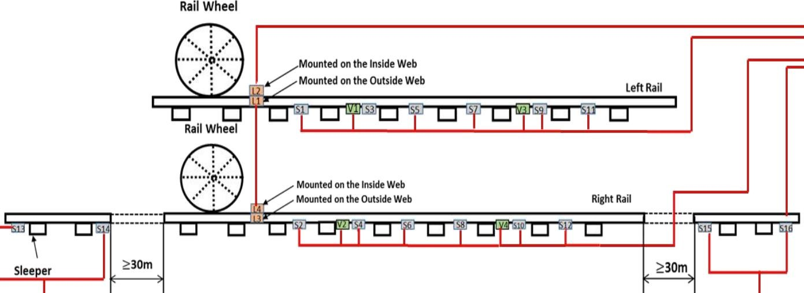

**Figure 2.5: WILD Sensor layout (Direction: Doddaballapura (DBU) to Yelahanka (YNK))**

Wheel Impact Load Detector (WILD) is the system that quantifies the impact of wheels onto the rail, as the train is on the run. Any defect or flat patch in the wheel results in generating high impact on the rail. Our WILD system captures the train information collected by Fiber Bragg Grating (FBG) sensors and detect the unhealthy wheels. Four trigger sensors (S13 (T1), S14 (T2), S15 (T3), S16 (T4)) are used to determine train occupancy in the WILD zone. Odd & Even vertical load sensors (S01, S03, …, S11 & S02, S04, ..., S12) are instrumented on two rails, each separated by an average distance of 65 cm. The data from these vertical load sensors is used to detect unhealthy wheels.

The FBG based sensing system designed for our WILD system is shown in Fig.

3.10. It consists of 24 FBG sensors and one Optical Interrogator. Out of the total 24 sensors, 20 sensors are kept in the measurement zone which spans 4.2 meter in length. The sensor configuration shown in Fig. 3.10 can detect a wheel defect anywhere on its circumference when the wheel rolls along the measurement zone

which is shown later section (in the wheel coverage analysis). As the diameter of the largest wheel used in Indian Railways is 1098mm and its circumference is 3449.5, we can conclude that 100% of the wheel circumference is covered by this system for rail wheel diameter from 780mm-1098mm. Two pairs of trigger sensors are kept at 30m away from the sensing zone on either side to detect the Entry and Exit of the train.

**Chapter 3**

**Requirement Specification**

**3.1 Software Requirements:**

* Operating System: Linux
* Language: Python
* Open-source libraries: Pandas, Matplotlib, NumPy

**3.2 Hardware Requirements:**

* FBG Sensors
* Interrogator

**3.3 Functional Requirements:**

Functional demand defines a set of software packages and the way the system should behave once instructed with specific inputs or conditions. These might embrace calculations, knowledge of information manipulation and the process and different specific practicality. During this, the system should follow these measures for the practical needs:

* Sensor should transmit data at a fast rate.
* Data transmitted should be tabulated, cleaned and stored in csv format.
* The algorithm should detect all the axle in the train data.

**3.4 Non-Functional Requirements:**

Non-functional needs measure the necessities that aren't directly involved with the particular function of the system. They specify the standards that may be accustomed to deciding the operation of a system instead of specific behaviors. Non-functional needs arise through the user desires, due to budget constraints, structure policies, the requirement for ability with different code and hardware systems or due to external factors such as Maintainability, Scalability, Performance, Reliability.

**Chapter 4**

**Implementation**

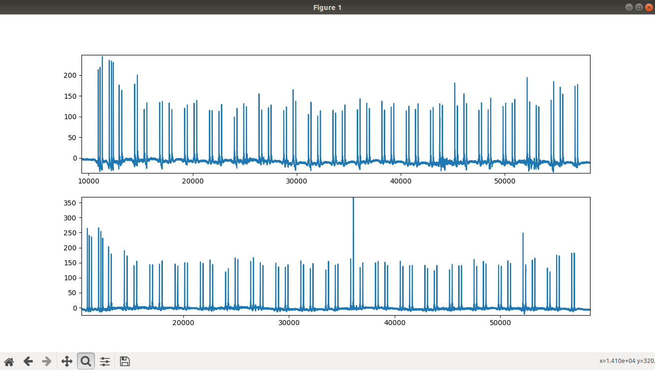

**Figure 1.1 CSV Data Plot**

There are 2 sensors placed on either side of each track. L1 and L2 on the left track gage, L3 and L4 on the right track gage. In the above graph, first graph is plotted using the values of sum of L1 and L2 data and the second graph is plotted for the values of L3 and L4. Each peak in the above graph represents one axle.

In the above graph first six axles together form the first locomotive, and the rest are wagons/coaches.

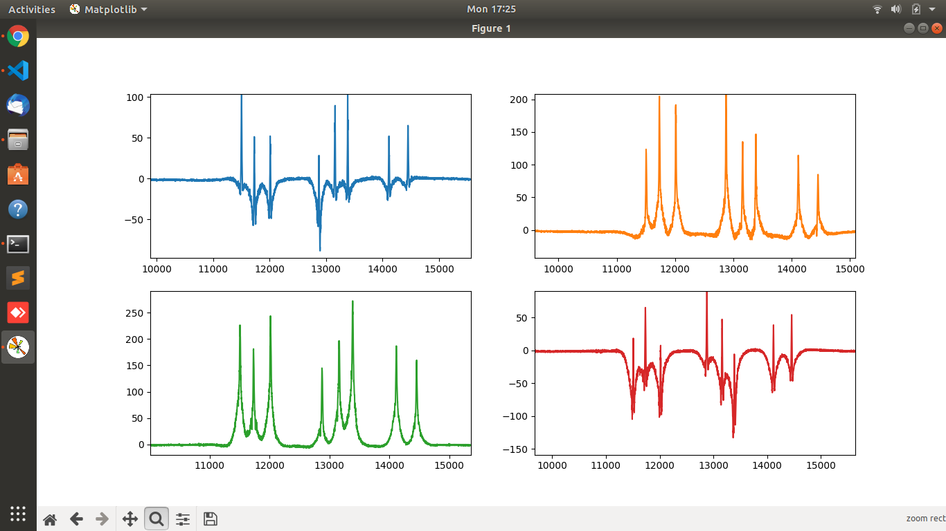

Blue – L1

Orange - L2

Green – L3

Red – L4

**Figure 1.2 Individual Lateral Load Sensors**

We then plot graph for individual Lateral load sensors The above graphs are plotted for L1, L2, L3 and L4 respectively. Here we can observe the actual peak is not starting from 0, instead it goes towards the negative direction and then again raises towards the positive direction. Hence, to find the actual peak the values have to considered from the trough to crest.

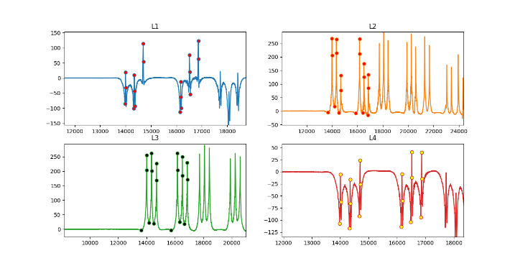

**Figure 1.3 Marking the peaks for each lateral load sensor**

The peaks of the first six axles in each lateral load sensor data are marked. Using this we will be able to find the actual peak value of each axle, even if decreases and then increases. Hence this value can be used instead of the previous peak values, as the peak values if taken from zero will give incorrect trends.

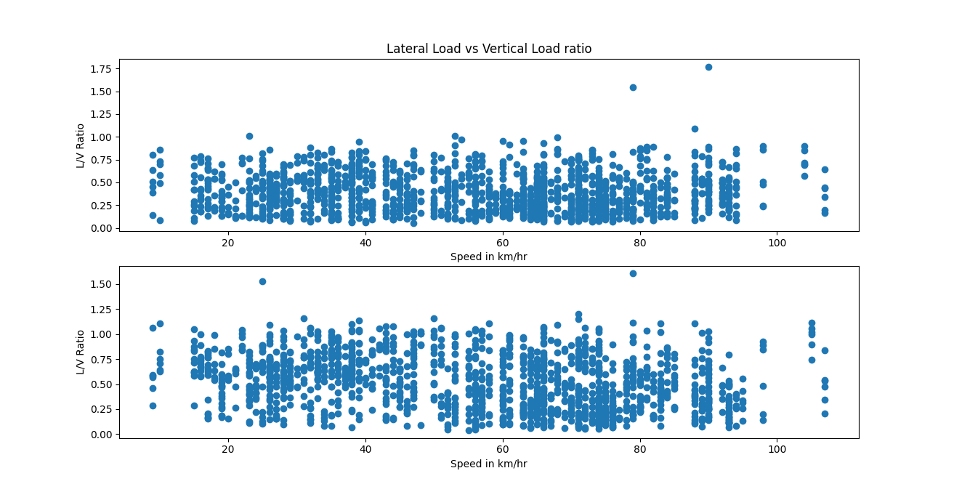

**Figure 1.4 Scatter plot of Lateral/Vertical ratio vs Speed**

In the above graph Ratio of vertical load (L1+ L2) vs lateral load (L1- L2) using the peak values is being plotted.

There are few points where the ratio is greater than 1, since the ratio shouldn’t be greater than 1. Those are the outliners.

No trend is observed in the above plotted graph.

After cross verifying, it is found that there were no issues with the calculation of ratio.

The problem was due to highly disturbed sensor data, which ended up giving false peaks. Many other methods were tried to eliminate those false peaks, but they are not successful. This problem can be rectified if the disturbance is the sensor data is removed.

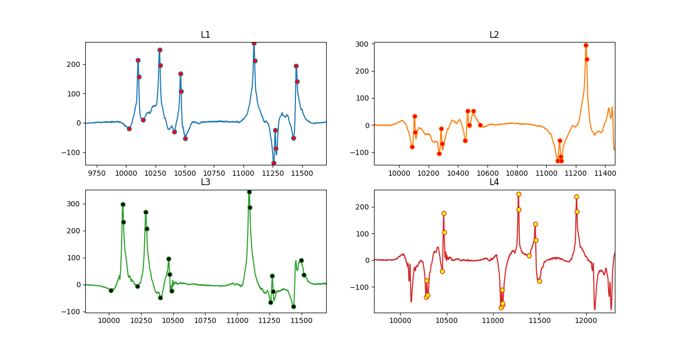

**Figure 1.5 Highly disturbed Lateral Load Sensors**

The above graph shows the disturbance in the lateral load data. There are many false peaks detected and in some places the peaks are not being detected at all. This is reason for the above-mentioned outliners

To check if there is any relation between Speed and the Lateral Load, another scatter plot is marked.

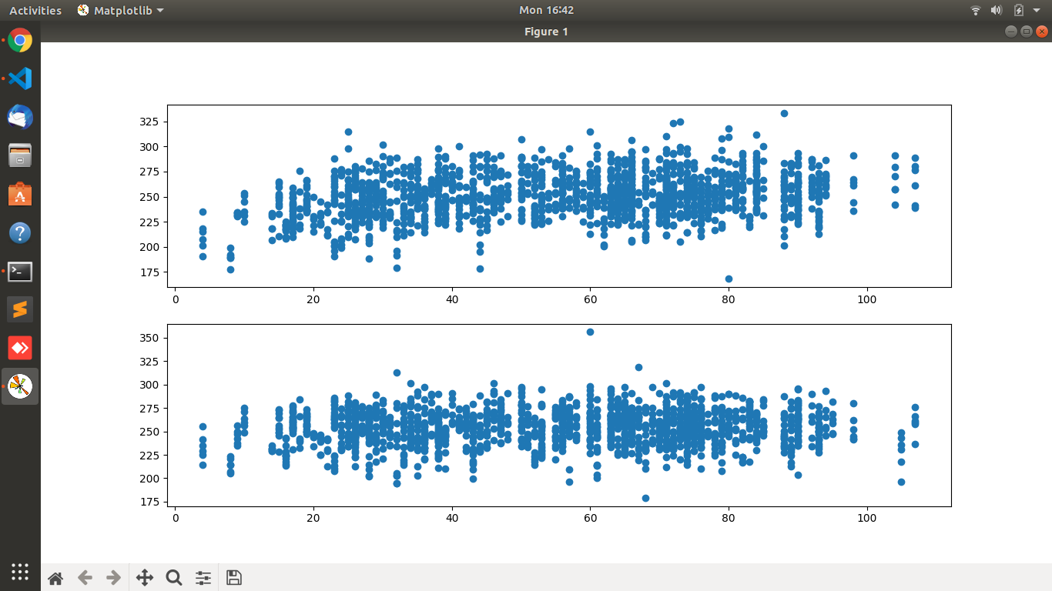

**Figure 1.6 Scatter plot of Speed vs Vertical Load(L1+L2)**

The above graph is a scattered graph in which peak value (sum of L1 & L2) is plotted against speed. Here it is observed that, there is a slight uptrend. When the speed increased, there is an increase in the peak values.

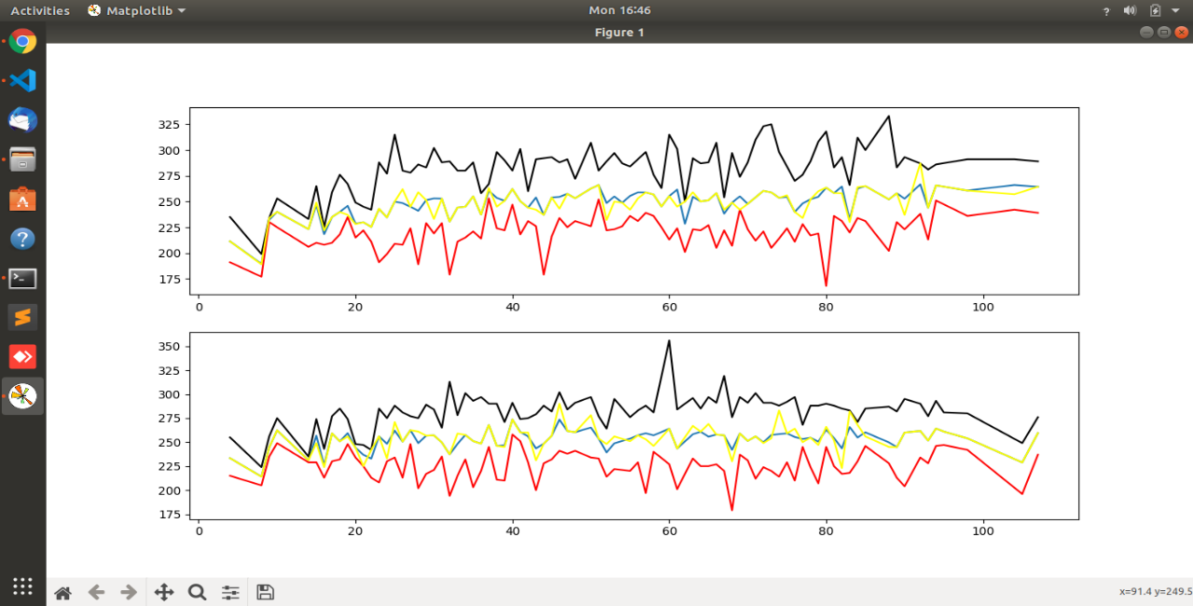

Blue - Average

Black - Maximum

Red – Minimum

Yellow - Mode

**Figure 1.7 Peak values vs Speed**

Above graph is plotted peak value vs speed. There is a very slight increase in the values as the speed increases. Hence an uptrend is noticed.

**Chapter 5**

**Conclusion**

There is not trend found in the Vertical load vs Lateral load, as there is an error in the data received due to high disturbance.

Hence it is concluded there is no trend or relation found with the currently received data. The hardware modification is required to get smoother data.

On comparing and analyzing the speed vs Lateral load data, a slight up-trend is observed.

Though there is not much major change in the values with respect to speed, this information can be used in the later stages when correct and smooth data from the Lateral load sensors is obtained.

**References**

[1]. https://wiki.python.org/moin/BeginnersGuide

[2]. https://pandas.pydata.org/docs/reference/api/pandas.DataFrame

[3]. https://matplotlib.org/stable/index.html

[4]. https://stackoverflow.com/

[5]. https://www.geeksforgeeks.org/

[6]. https://www.w3schools.com/python/